• Install Power BI Desktop and share the final screenshot of the report view page which appears when power desktop starts.

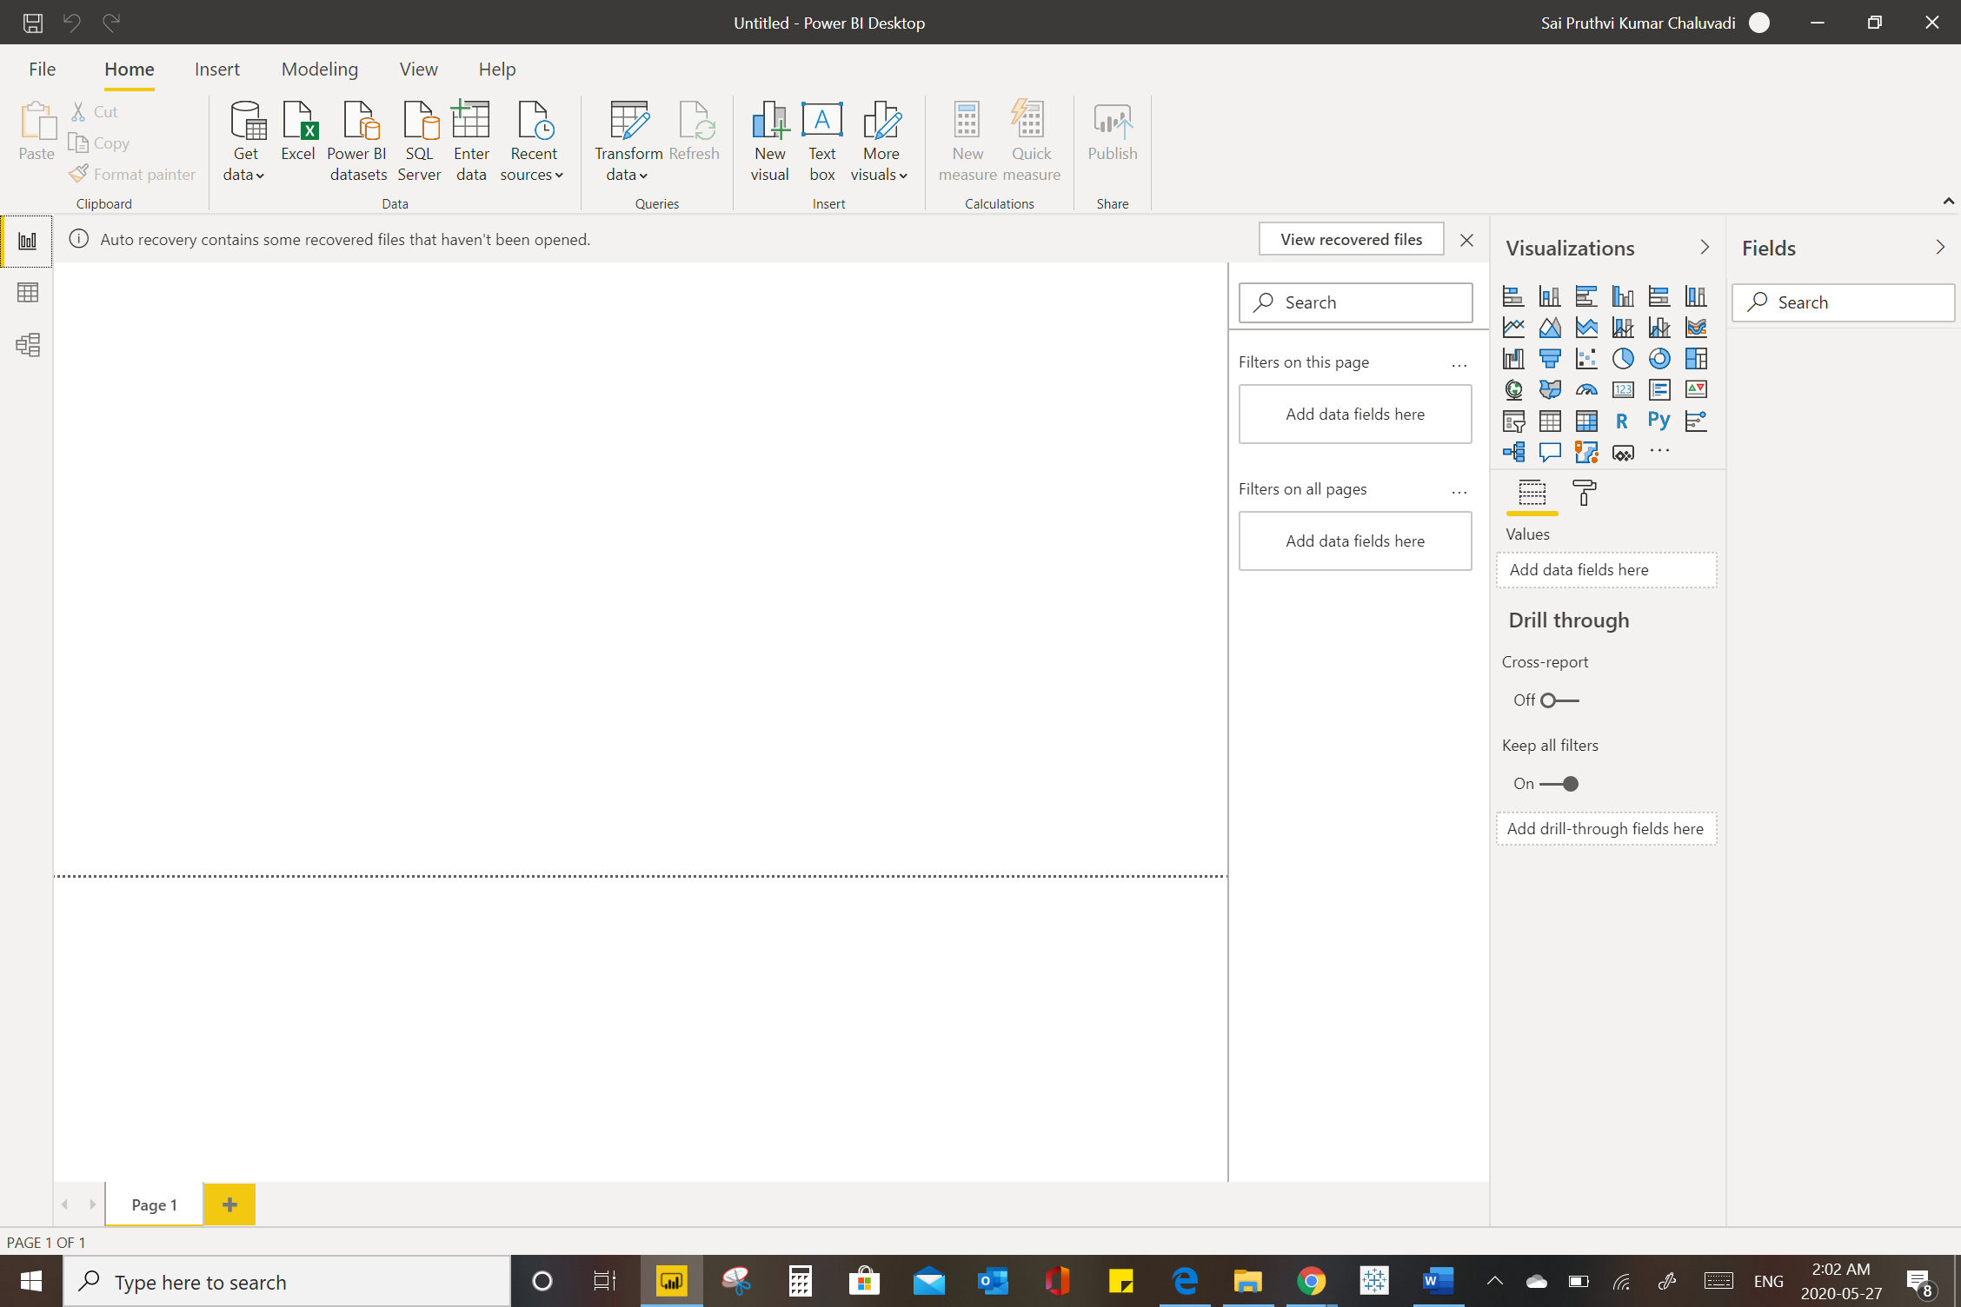

• Prepare a document and with the following screenshot

− Report View

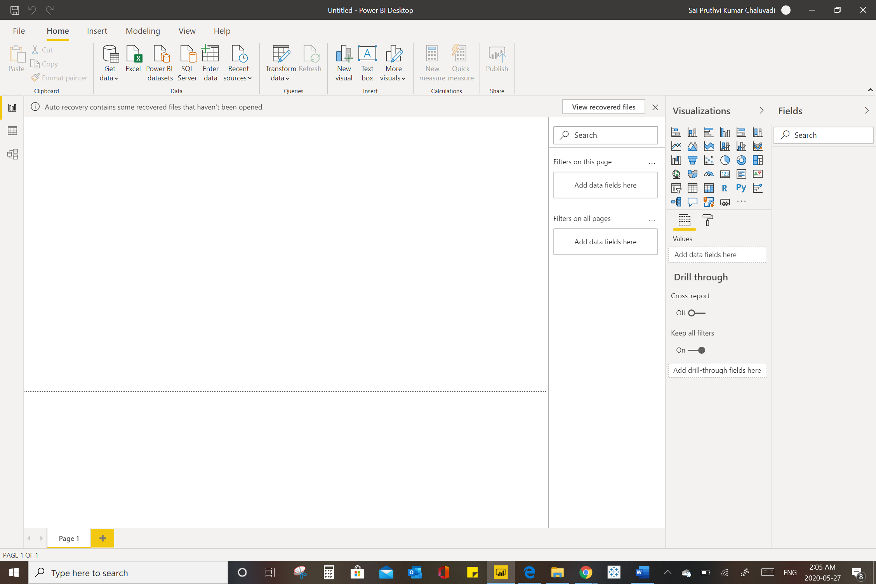

* Data View

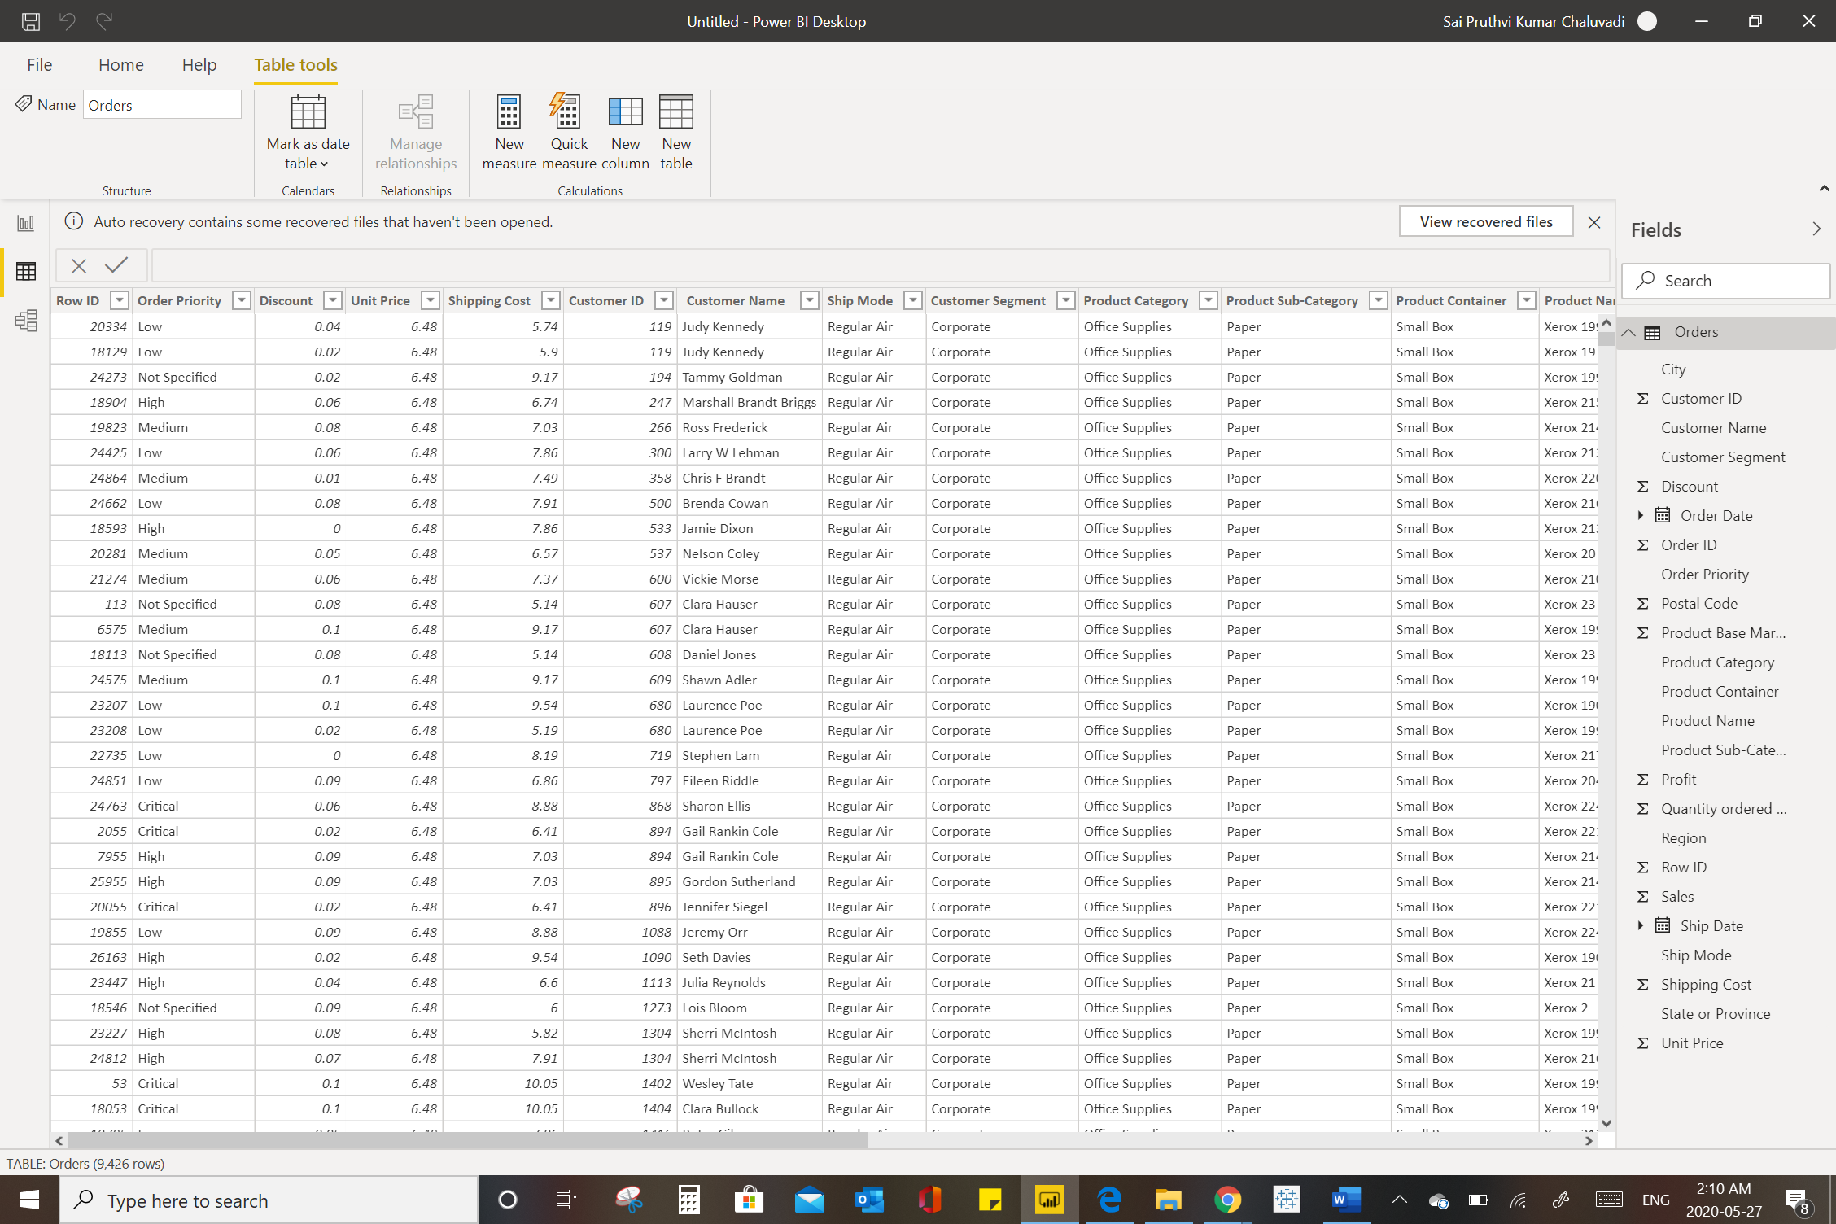

− Model View

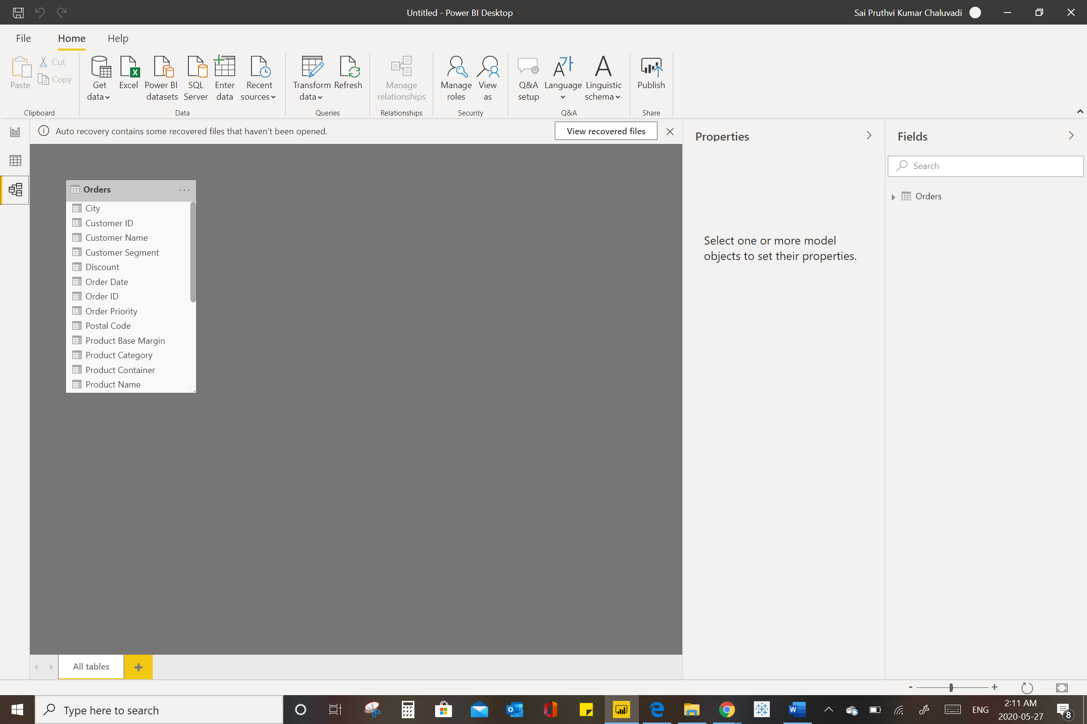

− Power Query Editor

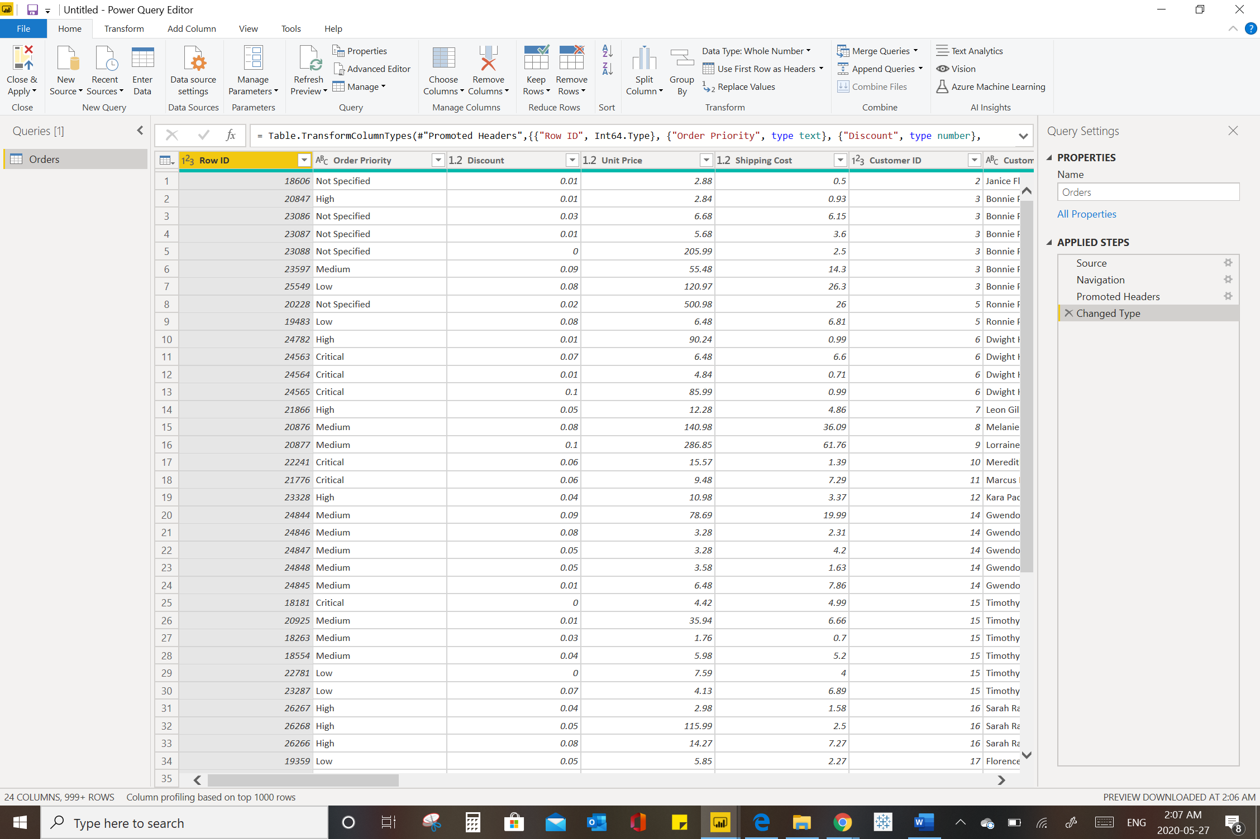

− Advance Editor

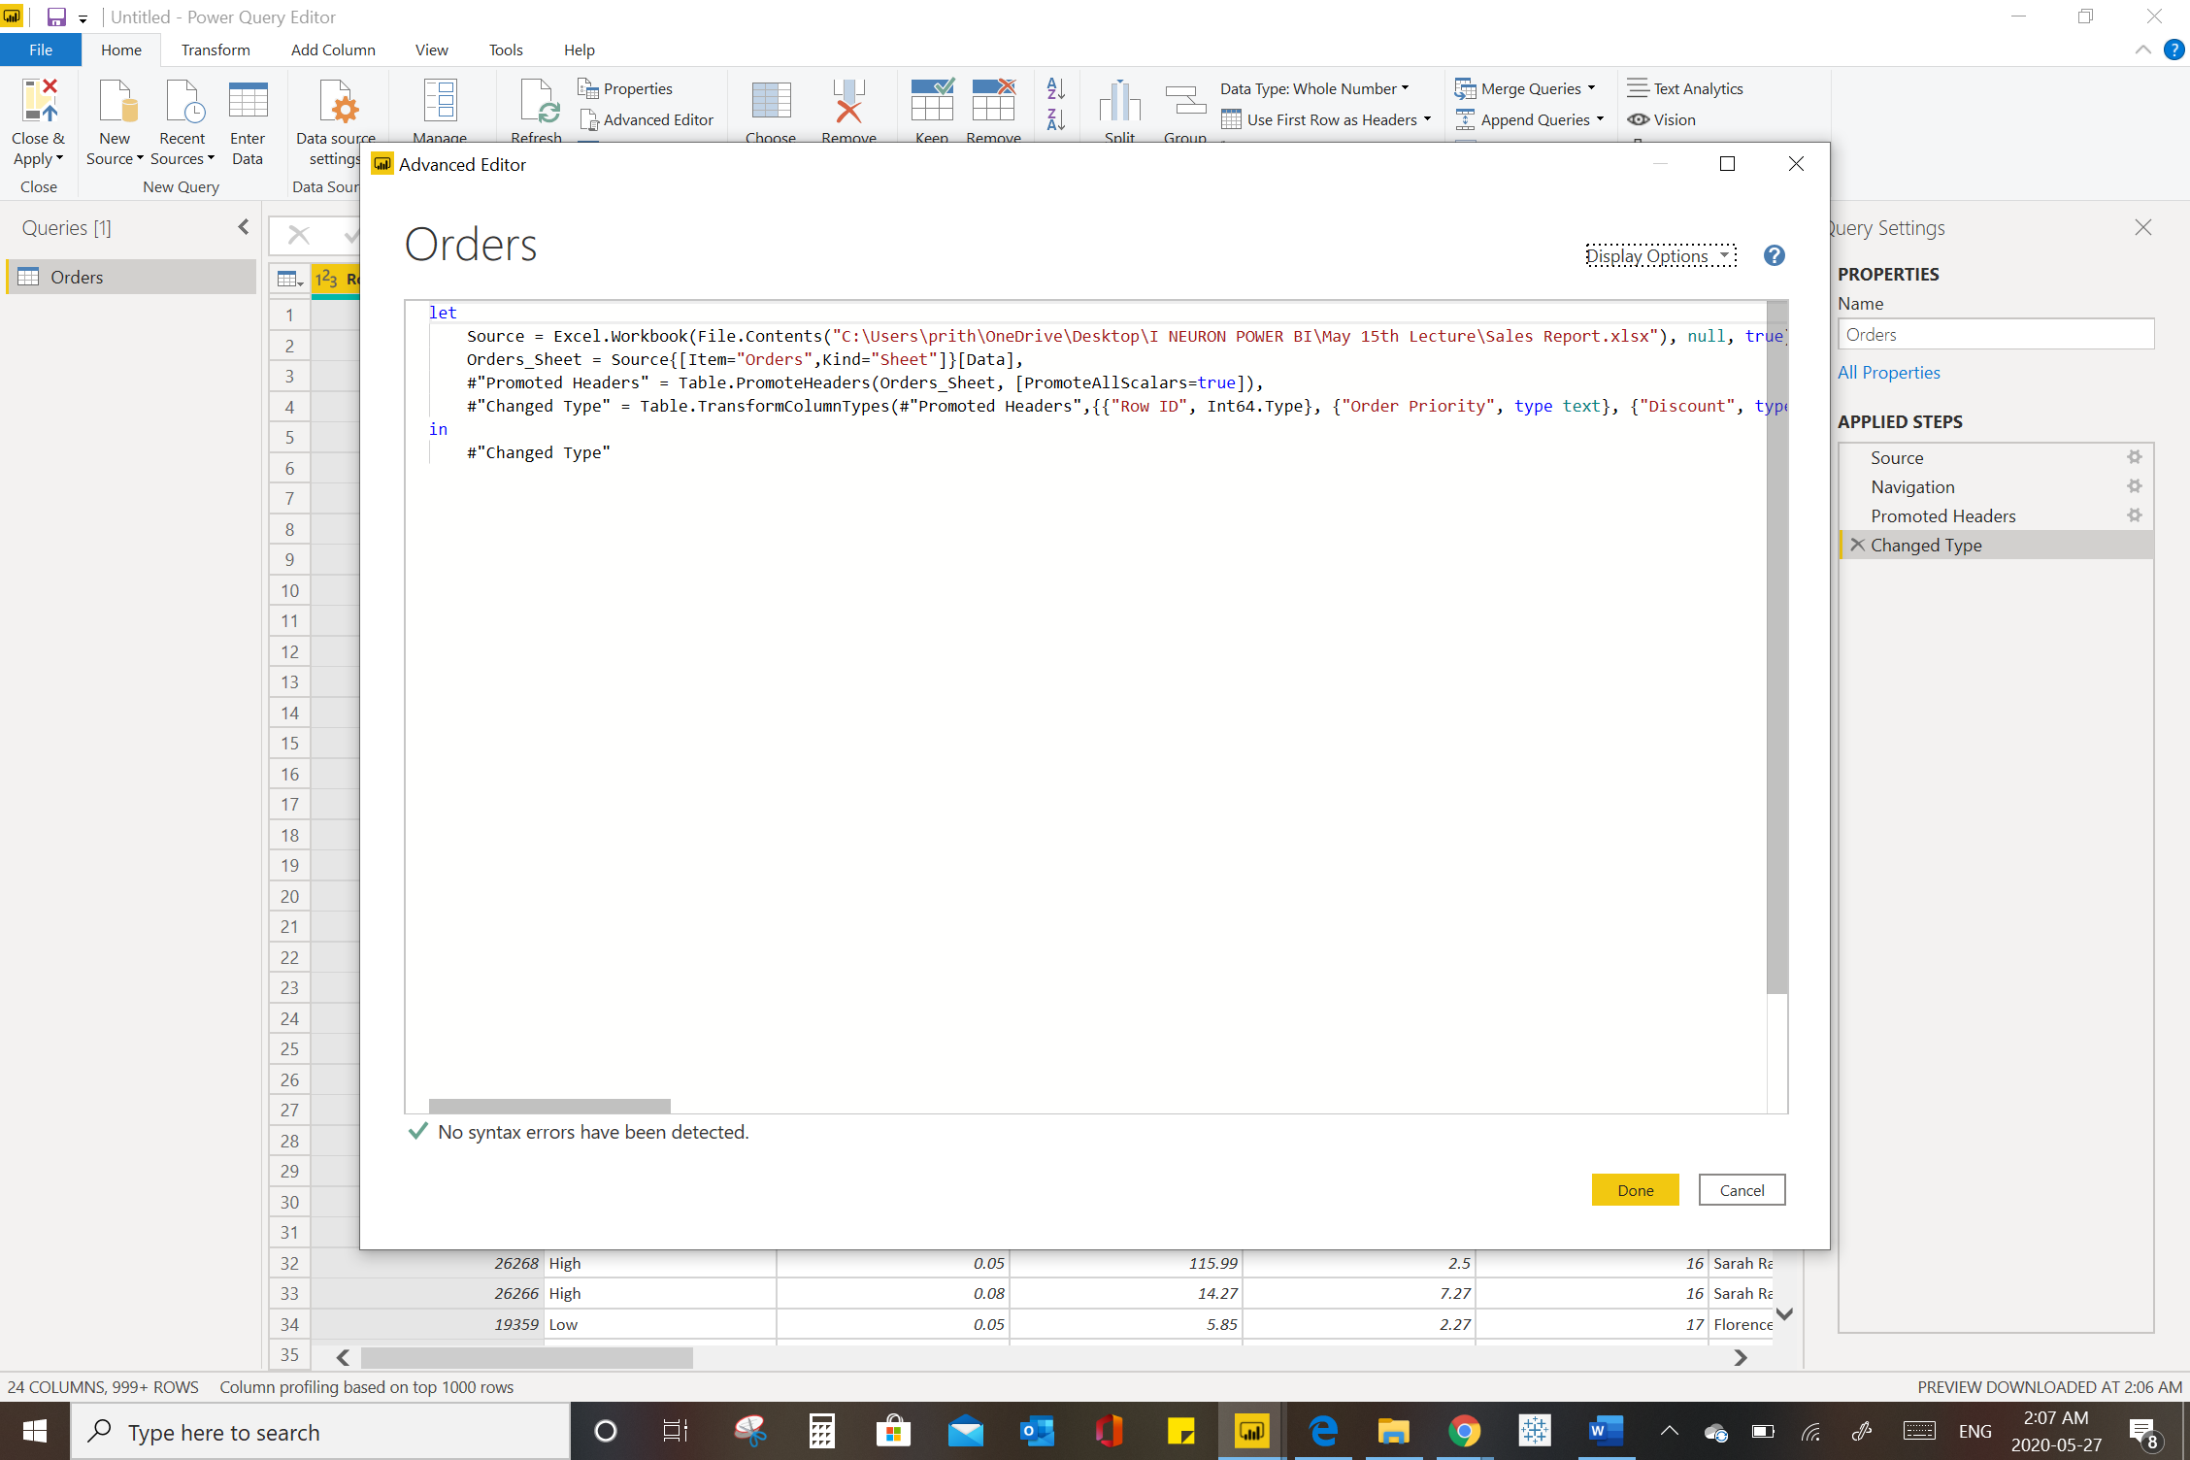

• Prepare a document with details of the following along with their price

− Power BI Desktop

− Power BI Pro

− Power BI Premium

The mentioned below are the differences between all the Three Power BI desktop, Power BI Pro and Power Bi Premium

Power BI is Microsoft’s data visualization software. It’s considered a leader in the pack, and user adoption has been growing rapidly. There are three types of Power BI that you’ll see on the Power BI [pricing page](https://powerbi.microsoft.com/en-us/pricing/):  Power BI Free, Power BI Pro, and Power BI Premium. In this article, I’m going to break down the differences between the three so you can know what you’re looking at.

Power BI Desktop

**This free version** is surprisingly functional. It allows you to connect to hundreds of data sources (no limit/restriction other than the amount of data you pull in), clean and prepare your data, and build visualizations (no limit). All of the types of visualization options in Power BI Pro are available in Power BI Desktop for free.

Power BI Pro

Power BI Pro is an additional $9.99/user/month ($12.20 CAD). It is also included in Office 365 Enterprise E5.  It adds a bunch of new features:

On-Premise Data Gateways

If your data resides On-Premise (not somewhere in the cloud), you can now connect to this data and analyze it. A common example of this is a self-hosted SQL database.

More Data Storage

Power BI Pro allows you up to 10 GB per Power BI Pro License. The free version caps you at 1GB per user.

Better Data Refreshes

In Power BI Pro, you can better schedule data refreshes so that your team always has the latest version of your data.

Sharing and Collaboration

The key feature here: If you want to share data, reports, and dashboards privately – you need to look at Power BI Pro. It allows you to share your data with individual coworkers, or publish enterprise-wide “content packs” and “apps” with row-level data security. **You can neither share with others nor consume shared content with Power BI Free.  Everyone that you want to share content with must  be assigned a Power BI Pro  license, UNLESS you decide to upgrade to Power BI Premium.**

Buy Power BI Pro

If you’ve found this article helpful, you can make your Power BI Pro purchase directly through Encore by [contacting us](https://www.encorebusiness.com/contact/).

Power BI Premium

[Power BI Premium](http://www.encorebusiness.com/blog/power-bi-premium-p1-vs-p2-vs-p3/) ***is not***a type of user license. Think of it as an upgrade to your entire company’s capabilities. Organisations with Power BI Premium have a super-powered server running their Power BI environment; this allows them to surpass some limits.  It is rather expensive ($5000-$20000/mo), so only the largest companies will get use out of it.

Separate Resources

No more “noisy neighbours”. Power BI Premium gives you your own processing environment, so your Power BI operations can’t be slowed down by other users that aren’t even within your company.

More Storage

Your company gets up to 100 TB of data storage to share in Power BI Premium.

Larger Datasets

Power BI Premium allows you to work with datasets up to 50 GB in size.

Free User Sharing Access

If you use Power BI Premium, then free users are able to consume shared dashboards.

More

Having your own processing capacity allows for other cool features. [Here’s a more in-depth overview.](https://powerbi.microsoft.com/en-us/documentation/powerbi-premium/)

Conclusion

In conclusion: Power BI Free is quite functional, but there are limits on data refreshes, sharing, and data storage that make Power BI Pro an attractive upgrade. Power BI Premium, on the other hand, is a super-upgrade that your entire organization can use if you want to process very large datasets.